PD_TC _08 - OrangeHRM_Personal Details _Enter the last Name with special characters

Launch the URL

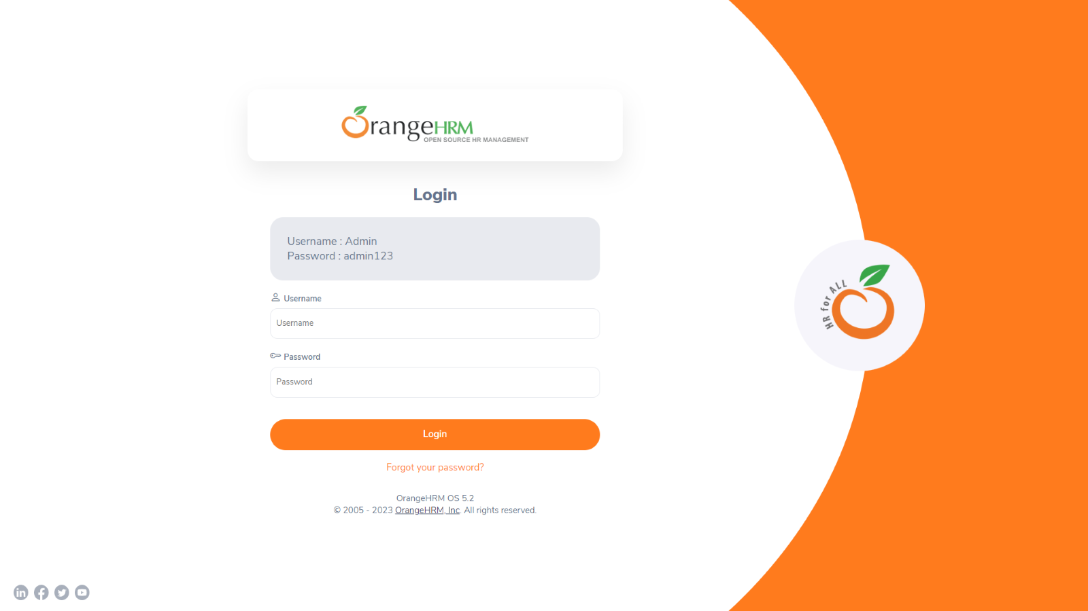

Login to the application with Valid credentials

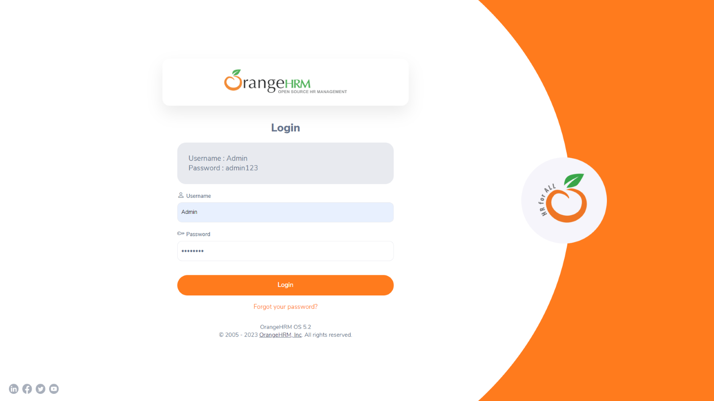

Logged successfully & navigated to personal details tab

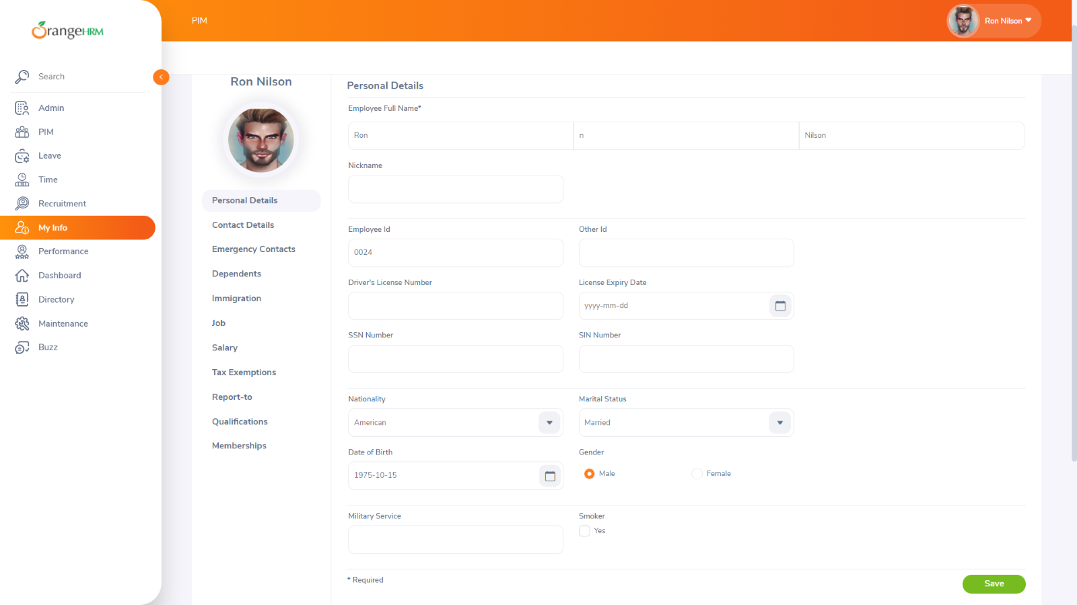

Enter the Last Name with special characters

